Semester One Examination, 2020

Question/Answer booklet
MATHEMATICS

If required by your examination administrator, please
place your student identification label in this box

SPECIALIST UNIT 3
Section One:

Calculator-free

WA student number: In figures

In words

Your name

Time allowed for this section Number of additional
Reading time before commencing work: five minutes answer booklets used
Working time: fifty minutes (if applicable):

Materials required/recommended for this section
To be provided by the supervisor
This Question/Answer booklet
Formula sheet

To be provided by the candidate
Standard items: pens (blue/black preferred), pencils (including coloured), sharpener, correction fluid/tape, eraser, ruler, highlighters

Special items: nil

Important note to candidates
No other items may be taken into the examination room. It is your responsibility to ensure that you do not have any unauthorised material. If you have any unauthorised material with you, hand it to the supervisor before reading any further.

Structure of this paper

Section | Number of questions available | Number of questions to be answered | Working time  (minutes) | Marks available | Percentage  of  examination
Section One:  Calculator-free | 8 | 8 | 50 | 52 | 35
Section Two:  Calculator-assumed | 13 | 13 | 100 | 98 | 65
 |  |  |  | Total | 100

Instructions to candidates

- The rules for the conduct of examinations are detailed in the school handbook. Sitting this examination implies that you agree to abide by these rules.
DO NOT WRITE IN THIS AREA AS IT
WILL BE CUT OFF

- Write your answers in this Question/Answer booklet preferably using a blue/black pen. Do not use erasable or gel pens.

- You must be careful to confine your answers to the specific question asked and to follow any instructions that are specific to a particular question.

- Show all your working clearly. Your working should be in sufficient detail to allow your answers to be checked readily and for marks to be awarded for reasoning. Incorrect answers given without supporting reasoning cannot be allocated any marks. For any question or part question worth more than two marks, valid working or justification is required to receive full marks. If you repeat any question, ensure that you cancel the answer you do not wish to have marked.

- It is recommended that you do not use pencil, except in diagrams.

- Supplementary pages for planning/continuing your answers to questions are provided at the end of this Question/Answer booklet. If you use these pages to continue an answer, indicate at the original answer where the answer is continued, i.e. give the page number.

- The Formula sheet is not to be handed in with your Question/Answer booklet.

Section One: Calculator-free 35% (52 Marks)
This section has eight questions. Answer all questions. Write your answers in the spaces provided.

Working time: 50 minutes.

Question 1 (6 marks)
A system of equations, where 𝑏 is a real constant, is as follows:

𝑥 − 𝑦 + 3𝑧 = 11
𝑥 + 2𝑦 + 2𝑧 = 3
2𝑥 + 𝑏𝑦 + 4𝑧 = 8

- Solve the system when 𝑏 = 3. (4 marks)

DO NOT WRITE IN THIS AREA AS IT WILL BE CUT OFF

- Interpret the system of equations geometrically when 𝑏 = 4. (2 marks)

Question 2
Polynomial 𝑃 is defined as 𝑃(𝑧) = 𝑧⁴ − 4𝑧³ + 14𝑧² − 36𝑧 + 45.

- Show that 𝑧 − 3𝑖 is a factor of 𝑃(𝑧). (2 marks)

DO NOT WRITE IN THIS AREA AS IT
WILL BE CUT OFF

- Solve 𝑃(𝑧) = 0, writing solutions in Cartesian form. (4 marks)

Question 3
Functions 𝑓, 𝑔 and ℎ are defined as

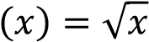
4
𝑓(𝑥) = 𝑥 + 3, 𝑔 , ℎ(𝑥) = .
2 − 𝑥

- Determine

  - ℎ ∘ 𝑔 ∘ 𝑓(6). (1 mark)

  - the defining rule for ℎ ∘ 𝑔 ∘ 𝑓(𝑥). (1 mark)

DO NOT WRITE IN THIS AREA AS IT WILL BE CUT OFF

- Determine the domain of ℎ ∘ 𝑔 ∘ 𝑓(𝑥). (2 marks)

- Determine the range of ℎ ∘ 𝑔 ∘ 𝑓(𝑥). (2 marks) Question 4
The graph of 𝑦 = 𝑓(𝑥) is shown below.
DO NOT WRITE IN THIS AREA AS IT
WILL BE CUT OFF

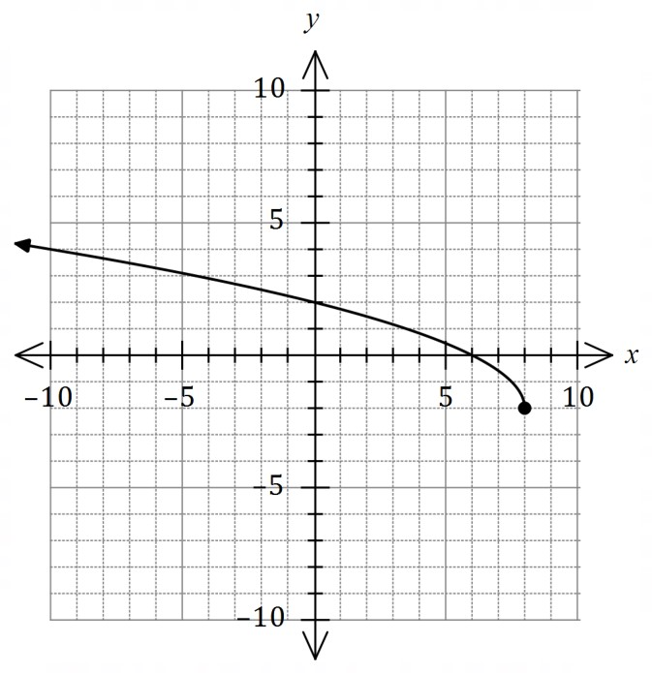

(a) Draw the graph of 𝑦 = 𝑓⁻¹(𝑥) on the same axes. | (3 marks)
(b) Given that 𝑓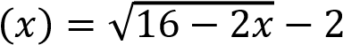, determine the defining rule for 𝑓⁻¹(𝑥). (3 marks)

Question 5 (8 marks)
−1 −3 3 0
Points 𝐴, 𝐵, 𝐶 and 𝐷 have position vectors ⃗𝑂𝐴⃗⃗⃗⃗ = ( 2 ), ⃗𝑂𝐵⃗⃗⃗⃗ = ( 1 ) , ⃗𝑂𝐶⃗⃗⃗⃗ = ( 4 ) and ⃗𝑂𝐷⃗⃗⃗⃗⃗ = (0).
4 7 −2 4

Note that |𝐮 × 𝐯| = |𝐮||𝐯| sin𝜃, where 𝜃 is the angle between 𝐮 and 𝐯 given by 𝜃 = cos⁻¹(̂𝐮 ⋅ 𝐯̂).

- Determine |⃗𝐴𝐵⃗⃗⃗⃗ × ⃗𝐴𝐶⃗⃗⃗⃗ | and use the result to explain why 𝐴, 𝐵 and 𝐶 are collinear. (5 marks)

DO NOT WRITE IN THIS AREA AS IT WILL BE CUT OFF

- Determine the Cartesian equation of the plane containing all four points. (3 marks) Question 6 (7 marks)
- Determine the complex cube roots of −1 in the form 𝑎 + 𝑏𝑖, where 𝑎, 𝑏 ∈ ℝ. (3 marks)

DO NOT WRITE IN THIS AREA AS IT
WILL BE CUT OFF

- Let 𝜔 be a complex cube root of unity, Im 𝜔 ≠ 0, so that 𝜔³ − 1 = 0.

  - Show that (𝜔 − 1)(𝜔² + 𝜔 + 1) = 𝜔³ − 1 and hence explain why 𝜔² + 𝜔 + 1 = 0.
(2 marks)

  - Simplify (2 + 5𝜔)(2 + 5𝜔²). (2 marks)

Question 7  The equation of line 𝐿 is  𝑥 − 2 𝑦 + 1 𝑧 − 1  = = .  2 −3 6 | (6 marks)
(a) Determine the vector equation of the line in the form 𝐫 = 𝐚 + 𝜆𝐛. | (2 marks)

DO NOT WRITE IN THIS AREA AS IT WILL BE CUT OFF

(b) The diameter of sphere 𝑆 is the segment of line 𝐿 between 𝑥 = 2 and 𝑥 = 6. Determine
the equation of the sphere. (4 marks)

Question 8  The locus 𝐿₁ of the complex number 𝑧 = 𝑥 + 𝑖𝑦 has equation |𝑧 − 6| = 2|𝑧 + 6|. |  | (7 marks)
(a) | Show that 𝐿₁ is a circle with equation 𝑥² + 𝑦² + 20𝑥 + 36 = 0. | (2 marks)
(b) | Sketch 𝐿₁ on an Argand diagram. | (2 marks)
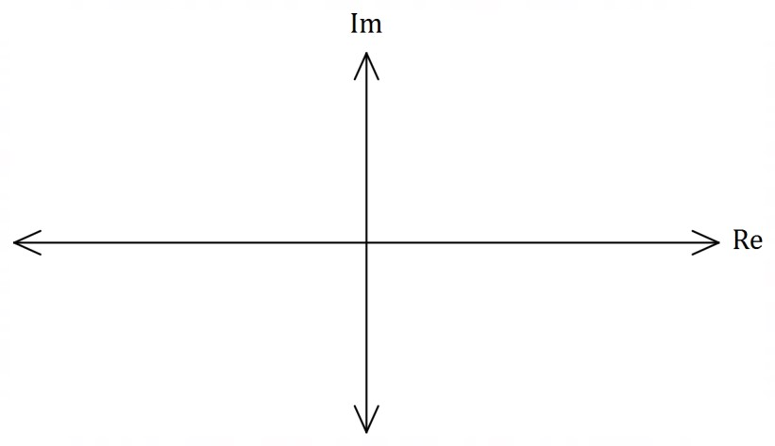
Another locus 𝐿₂ has equation 𝑤 ⋅ 𝑧̅ + 𝑤̅ ⋅ 𝑧 = 0, where 𝑤 = 4 + 3𝑖.

(c) Show that 𝐿₂ is a tangent to 𝐿₁. | (3 marks)
DO NOT WRITE IN THIS AREA AS IT WILL BE CUT OFF

End of questions
Supplementary page
DO NOT WRITE IN THIS AREA AS IT WILL BE CUT OFF

Question number: _________

© 2020 WA Exam Papers. Seton Catholic College has a non-exclusive licence to copy and communicate this document for non-commercial, educational use within the school.
No other copying, communication or use is permitted without the express written permission of WA Exam Papers. SN128-154-1.

